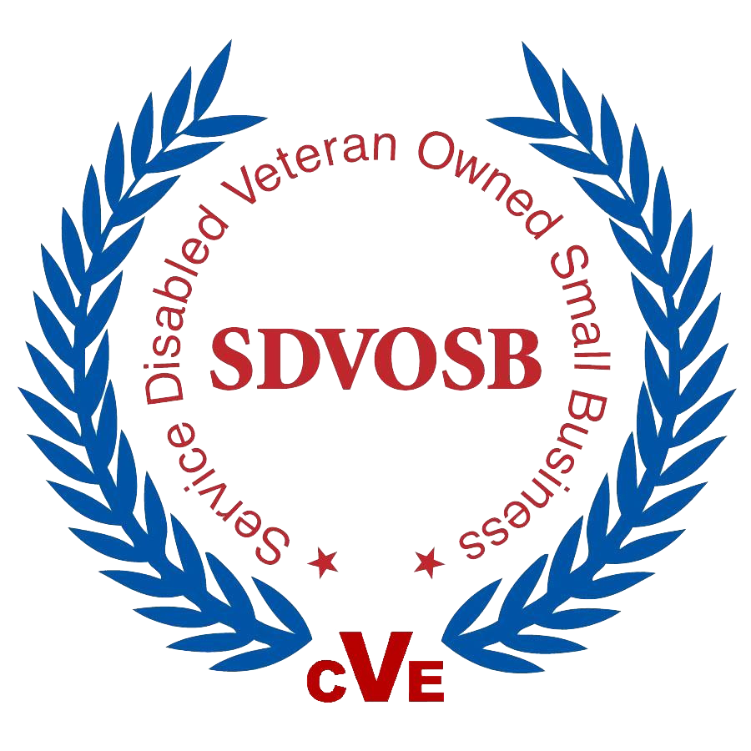
FRONTLINE SERVICES INC. CAPABILITY STATEMENT

Delivering Nationwide from our HQ: 6 Los Cruces Trail, Big Spring, TX 79720
Website: http://www.flservicesinc.com
Phone: 432-270-3933 or 575-408-0818
Contacts:
- Joshua S Nacey, Owner, SDVOSB, 307-389-2038, josh@flservicesinc.com
- Cashea Earls, COO, 432-270-3933, cashea@flservicesinc.com
- Cassie Magby, CFO, 575-408-0818, cassie@flservicesinc.com

SAM REGISTRATION ACTIVE UNTIL JANUARY 2022
- DUNS: 071037454
- CAGE CODE: 86m33
- Business Size: SDVOSB
- GSA Schedule: 65 II A 36F79720D0194
- DLA DAPA: SP0200-21-H-0021
- NAICS: Primary - 423450 Medical, Dental, and Hospital Equipment and Supplies Merchant Wholesalers
339112 Surgical and Medical Instrument Manufacturing
339113 Surgical Appliance and Supplies Manufacturing
339114 Dental Equipment and Supplies Manufacturing
622110 General Medical and Surgical Hospitals
- PSC CODES: 6515 Medical and Surgical Instruments, Equipment and Supplies
6520 Dental Instruments Equipment and Supplies
6530 Hospital Furniture, Equipment, Utensils and Supplies
6640 Laboratory Equipment and Supplies

ABOUT US:
Frontline Services Inc. is a CVE- certified Service Disable Veteran Owned Small Business (SDVOSB). Our primary mission is the patients we serve. We provide the most advanced and best-in-class medical devices and orthobiologics. We are committed to delivering the highest standard of care to the patients we serve by providing innovative solutions that improve outcomes in patient care.

PRODUCTS:
Clariance Products

- Clariance Spine Portfolio:
- Erisma-LP - Erisma-LP Evolution
- Erisma-LP MIS
- Idys-ALIF
- Idys-PLIF
- Idys-PTLIF
- Idys-TLIF
- Idys-C

Frontline Services Private Label Products
- AlphaFuse Moldable and Blend
- Charlie1 DBM Putty and Crush Mix
- EchoSponge Demineralized Cancellous Block
- DeltaStrand Cortical Fibers
- LimaCore Amniotic Membrane Allograft
- Structural Allografts
- Traditional Allografts
- Soft Tissue
- Acellular Dermis

Integrity Implants Products

- FlareHawk
- LineSider

Our Best Values/Differentiators:

- Partnerships the top medical device and biologic manufacturers allow us to provide the most advanced and effective technology.
  - ALLOGRAFT
  - CLARIANCE
  - STABILITY BIO
  - INTEGRITY IMPLANTS

- Speed to Deliver – Overnight Shipping
- One on One Customer Service Hotline 24/7

FRONTLINE SERVICES IS A SDVOSB WHO IS COMMITTED TO DELIVERING THE TOP OF THE LINE MOST INNOVATIVE SPINAL, SURGICAL, AND IMPLANT PRODUCTS TO OUR WARFIGHTERS AND OUR VETERANS.

“We Got Your Six originated with World War I fighter pilots referencing the rear of an airplane as the six o'clock position. At Frontline Services Inc. when we say we got your six we literally mean we got your back.”
Joshua S. Nacey Owner

